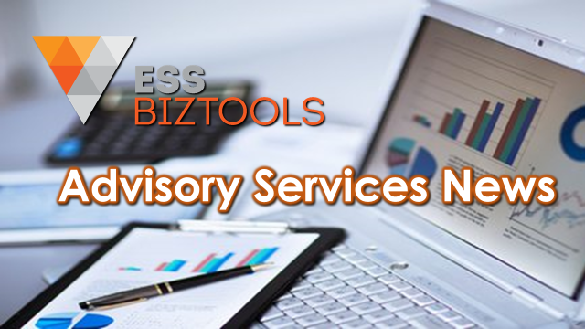

Hi…..

Welcome to this update on ESS BIZ TOOLS ADVISORY SERVICES NEWS.

The “Business Advisory Services Starter Package” Q&A video is available – please click here.

In the video I discussed:

Why Offer Advisory Services – we utilised the article in the “Australian Financial Review” on 20 March 2024 “Corporate Insolvencies Spike To A Decade High” to highlight that many SMEs are in great difficulty and that Bookkeepers and Accountants providing Advisory Services can assist those businesses that are still operating to survive and succeed in their businesses.

The key message is that SMEs need more direct Bookkeeping and Accounting Assistance!

I received a message “How can we utilise ESS BIZTOOLS material to instigate conversations with SME Clients.”

I indicated that the ESS BIZTOOLS package – “Advisory Intro” and the “Starter Package” include:

SME Needs Analysis – a great tool to use to encourage your client to open up on what business concerns they have.

Business Plus Newsletter – produced each month and over a year about 48 – 60 business related articles are prepared that you can talk to individual clients about, get their feedback and generate work requests.

Client Seminars And Webinars – pre-prepared ready for you to use to enable you to communicate with your clients

Client Mentoring And Coaching – this resource enables you to undertake a one-on-one discussion with the client about issues that might affect their business.

A practitioner rang me and said that talent is their big issue how can ESS BIZTOOLS assist?

I believe the challenge in 2024 is to create interesting and challenging work for your talent. If you do not do this, you will have trouble in attracting and retaining talented people. Why? Many people find that compliance type services becomes boring after a while. I believe you need to provide a mix of advisory as well as compliance work. In this way your talent will see the full picture and have a better understanding of how the entire accounting/commercialisation process fits together.

“What are the key attributes of the advisory services as discussed by ESS BIZ TOOLS?” Was another question.

It is important to be proactive about business information.

I believe the challenge is for Bookkeepers and Accountancy Firms to be offering “Commercial Information Services” to your clients.

Running a business is lonely for many people. Accountants and Bookkeepers fall into a unique group that is referred to as “Trusted Advisers”. I think this implies a responsibility that you are going to supply information to your clients about issues that might be confronting them in their businesses. This could relate to knowing that to claim the Research and Development Tax Rebate you have to be a company or it could mean that if the client is exporting or supplying services to overseas residents visiting Australia that they could be eligible to apply for the Export Market Development Grant.

If your client is having Business Funding Problems and there is no spare assets to be offered as security to a lender, having the knowledge of how section 708 of the Corporations Act or Crowd Sourced Funding Equity Raising operates can be a great comfort for an SME who is trying to find their way through a confusing process.

If you want to know more about Research and Development and Raising Capital from the public than just the basic information we have it all within ESS BIZTOOLS, you will just have to upgrade your subscription to a higher level and then you will be able to supply those services and earn additional fees.

If you missed these webinars – we are repeating the webinars at different times to make it more suitable for people to attend:

“Advisory Intro” webinar – Tuesday, 26 March 2024 at 1:30pm AEST – to register please click here.

“Business Advisory Services Starter Package” webinar Wednesday, 3 April 2024 at 1:30pm – to register click here.

If you have any questions or comments on the services provided by ESS BIZTOOLS to assist Bookkeepers and Accountants to offer Advisory Services, I would love to hear from you. Please send me and email – peter@essbiztools.com.au or telephone: 1800 232 088

We look forward to hearing from you as we proceed with the launch of Advisory Services for Bookkeeping and Accountancy Firms.

Thank you for investing the time in reading this email and we do look forward to your participation in our webinar.

If you would like to opt out from future emails, please click the link below to unsubscribe. Should there be any issue with the link, kindly respond directly to this email – peter@essbiztools.com.au and type Unsubscribe in the heading.

ESS BIZTOOLS Pty Ltd
Peter Towers - Managing Director
1800 232 088
peter@essbiztools.com.au
www.essbiztools.com.au

  
  LinkedIn
  
  Facebook
  
  Twitter
  
  Youtube

Want to change how you receive these emails?
you can update your preferences or unsubscribe from this list.

